Middle School

Mr. Francis
----- ----- ----- ----- ----- ---
Team 6A Math
Class Information
2019-2020

Reference

Teacher- Bob Francis bob.francis@chardonschools.org
440-285-4062

Textbook- College Prep Math, Core Connections 1

Commonly Used Links In 6th Grade Math-

Team 6A Website: http://cmsteam6a.weebly.com

Mr. Francis’s Class Website: http://cmsteam6a.weebly.com/mr-francis.html

On-line Textbook login page:

(Each student created their own username & password for their account. We had them tape a paper listing these to the inside cover of their assignment book.)

Child’s C.P.M. Online Textbook Username:

Child’s C.P.M. Online Textbook Password:

***The easiest way to access the above link is to use the posted link on Mr.
Francis’s webpage under ‘Links”…

***Mobymax login page: www.mobymax.com
(Each student received a printout w/ their username & password for this website. They were to tape it on the inside cover of their assignment book)

Child’s Moby Username:

Child’s Moby Password:

C.M.S. School Code: oh540

***Join Mr. Francis's 'Remind' group to receive occasional, but important messages related to 6A Math: Text the message @mathtopper to the number 81010.

***Mr. Francis's Google Classroom for 6a Math: tv1w5bi

***Parent/Student Infinite Campus Login:
http://www.chardon.k12.oh.us/InfiniteCampus.aspx

Ohio New Learning Standards: https://education.ohio.gov/getattachment/Topics/Ohio-s-New-Learning- Standards/Mathematics/Math-Standards.pdf.aspx
Welcome to Chardon Middle School & welcome to sixth grade math on Team 6A! I am looking forward to working with each student this year in helping them develop their mathematics skills & abilities. Each student will have the opportunity this school year to challenge themselves & improve their math skills. I truly believe that what is important is not where each student's math abilities are today, but rather where they will be as we work through the coming school year. Please consider keeping this document on file to refer to throughout the school year.
…………………………………………………………………………………………………………………………………………………

I. Overview:

Math classes at Chardon M.S. are 88 minutes in length, and our school utilizes the College Preparatory Mathematics series. This math program does an excellent job in helping students improve their individual skills as well as learn math through 'real world' applications of the subject. This math program is used by Chardon Schools in grades 6-12.

*Visit http://www.cpm.org if you would like to visit the website for C.P.M.

*Each student will not have a textbook to bring home each night. They will, however, have access to the online version of the book & the other helpful resources that are part of the C.P.M. website! Students will have a personal username and password to access the online textbook.

*Students without internet access will receive printed copies of the homework upon request.

*6th grade math focuses on a wide variety of skills. These skills are centered around the learning standards of the curriculum from Ohio New Learning Standards / Common Core. Please see the reference section of this handout to access the links for the websites that will provide additional information about Ohio’s New Learning Standards and the Common Core. Links to these websites can also be found under the ‘LINKS’ section of the class webpage. We will work very diligently to prepare students for the standardized tests our sixth graders will take. These tests are known as the A.I.R. Test. A.I.R. stands for American Institute of Research.
II. Grading / Homework:

Grades are calculated based on points accumulated during the grading period. The grading scale is:

90-100% - | A | 60-69%- | D
80-89%- | B | Below 60%- | F
70-79%- | C

Course points will be earned in 3 different categories. These categories are ‘weighted':

Assessments w/ Resources  (Summative)  (60% Of Each Qtr. Grade) | Assessments w/o Resources  (Formative)  (20% Of Each Qtr. Grade) | Coursework  (Homework / Classwork)  (20% Of Each Qtr. Grade)
Chapter Tests  Quarterly Tests  ‘Checkpoint’ Quizzes  Summary- Points in this category are earned on tests & quizzes by correctly answering each  question & demonstrating the required skills. They are graded for being 'right or wrong’ | ‘Exit’ Slips  Test & Quiz Corrections  Presentations & Projects  Summary- Students must correctly answer the questions on these assignments in order to receive the points.  However, they can ask for help as needed, & they can redo & correct as many times as needed to earn the points within the time frame given. At the end of the assignments, students typically receive full credit or zero points based on whether or not they successfully demonstrated the skills with the resources provided. | Homework  Review Guides  Moby Max Assignments  Most ‘In-Class’ Work  Summary- These points are earned by completion & effort. Points are not awarded for being correct. Characteristics such as attempting all questions, showing work, neatness, etc. are factors  in earning points in this category.

*Late Work Policy- The policy on late homework varies based on the assignment. Assignments that can be turned in for late credit should be turned in the next day to receive partial credit. Missing work should always be turned in before reaching the quiz or test over that material! Students may be required to complete missing work for no credit in order to be able to retake a test. Further explanation will be provided to the students in class on this topic. Lastly, students cannot earn late credit for Moby Max assignments, exit slips, and test corrections. Because students have at least a one week window for those, they must be completed within the time frame given.
*The ’45 Minute ’ Rule- Different students work at different rates in math. I do not want students suffering for hours on assignments that they may not understand for hours at home. If students are not understanding an assignment, they should give it their best effort & use all of the resources available to them (webpage, parental help, notes, etc.) to try to successfully complete the work. However, I would prefer them to not exceed 45 minutes on typical math homework. If they are still struggling, the student can bring in the work that they did complete and show what they attempted. If a parent writes a short note on the homework & signs it, indicating there was a problem understanding the material, I will give the student full credit on the assignment and then make sure they get the help they need the next day.

Along with this, please realize that students will be given time to get work completed as much as possible in school. Regardless of how much time is given, students vary in their ability to use this time productively. This is a good conversation to have with your son or daughter that goes beyond math class. The more efficiently they can utilize school time, the number of minutes needed at home for homework will reduce!

*’No-Name Papers’- For a variety of reasons, students must put their first and last name on all assignments. Papers turned in without a name will lose 1 pt. and be hung in the classroom for 24-48 hours. If it is not claimed in a day or two they are then thrown away.

……………………………………………………………………………………………………………………………………………….

III. Moby Max:

*In addition to our textbook, we will also utilize the online math program of Moby Max to drill math facts, review important concepts, & build additional math skills on an individualized basis. Moby assignments are assigned on most Tuesdays in one of
the following modules: Fact Fluency, Math Lessons, or Test Prep.

Students then have until ‘midnight’ of the following Monday to complete the work. Moby assignments are typically done outside of math class, during class when other work is completed early, or during the common work times provided during the school day.

*Since students have an entire week to complete Moby assignments, late credit is not available unless there are extenuating circumstances. However, it is important for students to
understand the procedure for when they get stuck on material while working in Moby:

a) Simply stop for the evening & ask for help the next day in class.

b) If the problem occurs on the last day before the due date, students can simply bring in a short note from a parent indicating they tried to do the work but got stuck. We will provide help the next day and provide a short extension to finish.

One final Moby note is that all students will be given handouts with screen shots that explain how to check if assignments are completed!

MOBY MODULES COMMONLY USED IN 6TH GRADE MATH

Fact Fluency- Drills basic math facts in each of the four basic operations. Sessions are personalized to each student both in terms of which facts are drilled, but also the speed in which the problems are presented. Points are earned by drilling for an assigned number of minutes per week.

Math Lessons- Math lessons are assigned on an individualized basis based on each student’s math skills as determined by a placement ‘test’ taken at the beginning of the school year. Math lessons are reached in Moby by selecting the green ‘Math’ icon on the top left main screen. Points are earned by completing a lesson within the week timeframe.

Test Prep- Test Prep is a module that strives to prepare students for the standardized tests taken in the spring. Students will work through the 6th grade math standards as they work from week-to-week when Test Prep is assigned. Points are earned by working with this module for the assigned number of minutes for the week, trying a fair number of problems, and working to a fair level of accuracy.

IV. Attendance / Absences:

When students are absent, they should refer to the ‘Homework Calendar’ on the course web page to learn what they missed. Of course, help will be provided to them to understand what was missed if necessary. Students can also use the website to download class notes, handouts, review sheets, etc. It is the responsibility of the student to see the teacher regarding missed classes and homework.
Typically speaking, students will have an equal number of days to make up assignments, tests, & quizzes that they were absent. This is in accordance with the C.M.S. student handbook. However, as with many things in life---communication is the key. If a student needs an extension to get work completed, I have never denied them, provided they have communicated with me ahead of time. Absent work not made up will become 0’s in the gradebook, so it is very important that students are diligent about making up missed work.
V. Materials:

The following materials will be needed for math class this year:

*Pencils! *Loose-leaf notebook paper
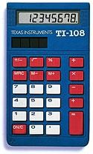
*Graph paper *Red pen for making corrections
*Ruler *Calculator
*2 dry erase markers *C.M.S. assignment book

Materials Notes

*Paper- Some students elect to complete all of their homework on graph paper as it helps them with neatness & keeping columns straight. This eliminates needing a separate loose-leaf notebook for math.

*Binders- Don't spend a lot of money! As long as the kids have a means to stay organized, most any system will suffice! Some students do a great job keeping organized by simply using a basic folder with pockets & prongs.

*We ask students to leave the dry erase markers in the room so they will always be in the room
& not in their lockers. It also allows teachers to be sure the markers being used on the dry
erase lap boards are not permanent ‘Sharpies’.

*Calculators- Any basic calculator is sufficient!

VI. Retesting:

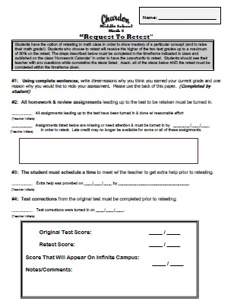
Students will have the option of retesting on most unit tests & most quizzes. The procedure for this will be to fill out a 'Request To Retest' form in the classroom or off of my website. This form outlines the steps the student must take in order to retest.
These steps are summarized as follows:

*All homework assignments that prepared the student for the test must be completed. Students may be required to go back & complete missing work not for grade credit, but for understanding of the material.

*The student will schedule a time with a teacher to get extra help on the material.

*Test corrections from the original test must be made & turned in.

*Students will also write a few sentences explaining why they think they earned the original grade they did.

All of the above should be completed within the timeframe given unless there are extenuating circumstances. After retesting, students will receive the higher of the two scores as their new grade on Infinite Campus.
…………………………………………………………………………………………………………………………………………………

VII. Conduct:

Students can help themselves to achieve success by following the basic rules of the classroom.

These rules are common sense and will be discussed with the students on the first day. Typically, 'strikes' are given to 6A students across the team up to the third offense. On the third offense, a conference is held with the student and a message will go home to parents. On the fourth offense, a team-issued detention is given (no record or dealings w/ the office). Should a fifth problem occur, it will result in an office referral. Strikes reset with each new quarter. Obviously, if the behavior incident was more serious in nature, the 'strike' plan will be bypassed and result in an office referral.

……………………………………………………………………………………………………………………………

VIII. Webpage:

There is a webpage that is dedicated to this math class that should be very helpful to you!

http://cmsteam6a.weebly.com/mr-francis.html

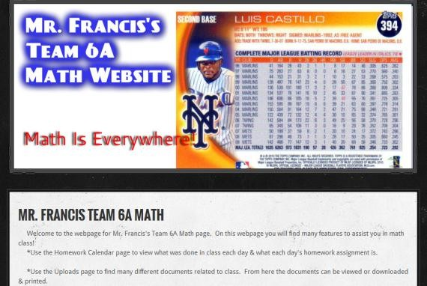
Please bookmark this site so that you can easily access it throughout the school year.

Below is a summary of some of the features of the website:

-'Homework Calendar'- Click on this link for an explanation of what we covered in class each day. You will also find homework assignments listed here. THIS IS UPDATED DAILY.

-'Links Page'- Here you are provided easy access to resources for math class including 'Moby
Max’, 'College Prep Math' textbook site, Infinite Campus, etc.

-'Downloads Page'- Here you will find many documents, papers, & resources used in class uploaded to allow for viewing and/or printing.

-'Extra Help Page'- This is a great resource if you get stuck at home! Here you will find links to videos & documents to provide help in various skills used in class. For example, links to videos explaining how to divide fractions, order of operations, & finding the area & perimeter of an irregular shape & much more can be found here. You will also find ‘Extra Help’ packets here for each chapter covered in 6th grade. These packets contain additional explanation of concepts, practice problems w/ answers, etc.

…………………………………………………………………………………………………………………………………………………

IX. Infinite Campus & Keeping Up w/ Your Child’s Progress

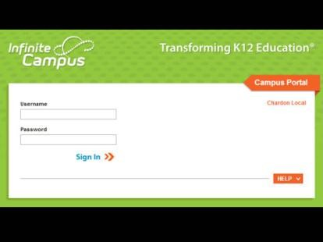
Through the use of Infinite Campus, you can view your child's grades

24 hours a day from any device that has internet access. Assignments & grades are updated on a regular basis (At least once a week)! Please check your child’s grades at least once a week. Parents will also receive information about your child’s math class
emailed through Infinite Campus once about every 1-2 weeks. These emails will inform you of upcoming due dates, tests, quizzes, etc.

NOTE: Use the Homework Calendar daily to learn about what was done in class each day & when it is due.
Use Infinite Campus to check on grade status & if your student is keeping up with work.
……………………………………………………………………………………………………………………………………………
X. Extra Help / Success In Math

One of the beliefs that will be communicated to students this year is that their success in math class will be determined by them through their work ethic! I will provide them with every tool & opportunity to improve in math class. There will be opportunities for students to receive extra help when needed during school time & during after-school opportunities. The most important factor is that kids/parents communicate when they feel extra help is needed, and we will find a way to get it done!
There will be opportunities to receive additional help, both during the school day and before or after school. These opportunities will be communicated through announcements in class, Infinite Campus messages, and posted to the class homework calendar. Lastly, after-school help sessions can be used for students who want to try additional more challenging material as well.
…………………………………………………………………………………………………………………………………………………

XI. Wrap Up…

I am looking forward to a great year. If students take advantage of all of the resources available to them at Chardon M.S., they can experience success! Please feel free to contact me anytime if you have any questions about your child’s progress.
Thank you, Bob Francis

(Please sign & return the attached slip which will be worth 2 pts. on your child's homework grade)

I have received the course outline for the Math 6A program at Chardon M.S. with Mr. Francis.

Student Name:
(Please Print)

Parent contact email:

Parent/Guardian Signature: Date: ____________

